**Year 10 Rapid Reactions Quiz 1 Revision**

1. Complete the terms for each definition below:

|  |  |
| --- | --- |
| Term | Definition |
|  | Number of protons in the nucleus of an atom |
|  | Number of protons and neutrons in the nucleus of an atom |
|  | Number of electrons in the outside shell of an atom |
|  | Vertical column in the periodic table |

1. Label the atom below and complete the table.

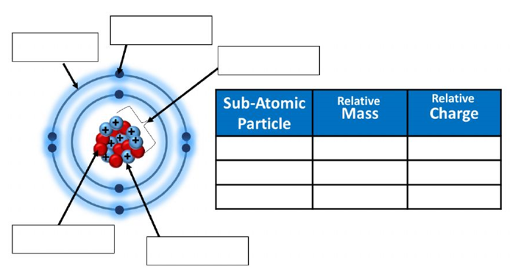

1. Complete the table below

|  |  |  |  |  |  |
| --- | --- | --- | --- | --- | --- |
| **Atom** | **Name of Element** | **Atomic Number** | **Mass Number** | **Number of Electrons in Neutral Atom** | **Number of Neutrons** |
| $$\begin{matrix}23 \\ 11\end{matrix} Na$$ |  |  |  |  |  |
|  | Chlorine |  | 35 |  |  |
| $$\begin{matrix}27 \\ 13\end{matrix} Al$$ |  |  |  |  |  |
|  |  |  |  | 9 | 10 |
|  | Bromine |  |  | 35 | 45 |

1. Complete the table below

|  |  |  |  |
| --- | --- | --- | --- |
| **Symbol** | **Number of Electrons** | **Electron Configuration** | **Electron Configuration diagram** |
| F | 9 | 2,7 |  |
| P |  |  |  |
| Si |  |  |  |
| Na+ | 10 |  |  |
| Ca2+ |  |  |  |
| Cl- |  |  |  |

1. Explain the difference between a **period** and a **group** in the Periodic Table. What do each of these tell us about the properties of elements?
2. A student conducted an experiment and made the following observations:

* Potassium is more reactive than sodium
* Sodium is more reactive than aluminium
* Fluorine is more reactive than bromine

**Explain** these observations using the diagram of the periodic table below.

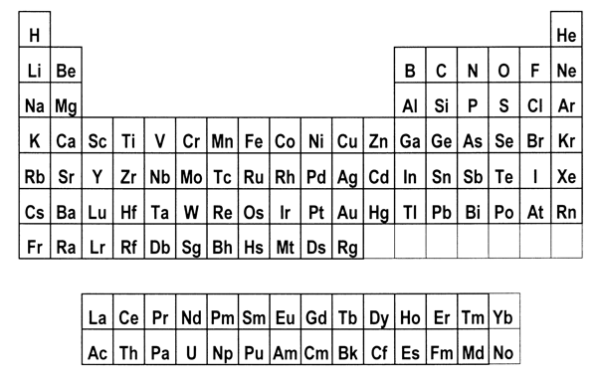

1. Complete the following table below for each bonding type by sorting the given terms into the correct row.

|  |  |  |  |  |
| --- | --- | --- | --- | --- |
| Left, Centre and Right | Soft if solid | Shared electron pairs | High for solids | Low to high |
| Left and Centre | Brittle and hard | Oppositely charged ions | Not as solids but does when molten | High |
| Right | Malleable | Delocalised electrons and positive ions | Not as solids or liquids | Usually low |

|  |  |  |  |  |  |
| --- | --- | --- | --- | --- | --- |
| Type of Bonding | Periodic Table location | Structure | Bond contains: | Conductivity | Melting Point |
| Metallic |  |  |  |  |  |
| Ionic |  |  |  |  |  |

1. In terms of bonding, explain why copper can be stretched into wires but copper chloride cannot.
2. Complete the following table by writing the correct chemical formula for each compound formed.

|  |  |  |  |  |
| --- | --- | --- | --- | --- |
|  | FLUORIDE | NITRIDE | CARBONATE | PHOSPHATE |
| POTASSIUM |  |  |  |  |
| MAGNESIUM |  |  |  |  |
| AMMONIUM |  |  |  |  |
| ALUMINIUM |  |  |  |  |
| LEAD IV |  |  |  |  |